Survival Game

COMP-4990 Final Delivery Report

Team 19

Dariq Ahmed, Jason Cala & Ravi Trivedi

ahmed16r@uwindsor.ca

calaj@uwindsor.ca

Table of Contents

Acknowledgement 2

Introduction ……….. 3

Game Requirements … 4

Tools and Components … 4

Features and Functionalities …. 5

Project Demo … 13

Conclusion and Limitations .. 14

Github Link …. 14

**Acknowledgements**

This section acknowledges the major resources we utilized throughout the process of building this project.

1. Online assets used (environment + characters)

* Environment Assets:
  + Old Sea Port
  + 40 prefabs including ( water, fire, stone structure, wood structure)
  + Dark Rocks – Cave Environment
  + A collection of 11 hand-sculpted assets, each with high-res textures and 3 LOD stages, that can be used as standalone rocks or for building caves and cliffs. Includes a beautiful example scene.
  + Winter Tundra – Ice and rock pack
  + All snow-covered assets include versions without snow, for a total of over 230 prefabs!
  + Butterfly – Animated
  + House Pack
  + RPG/FPS Game Assets for PC/Mobile (Industrial Set v2.0)
  + Flooded Ground
  + Terrain Simple Asset pack
  + Grass Flower pack free
  + Outdoor ground texture
  + Conifers
  + Bootcamp – hdrp
  + Unity Terrain – HDRP Demo Scene
  + Fantasy Forest Environment
  + Monsters – Wraith (98$)
  + Alien Fantasy Forest (54.99$)
  + Coniferous Forest (49$)
* Characters Assets:
  + Maximo’s different characters
  + Maximo’s different animations
  + Humanoids Monsters Pack (4.99$)
* Audio Assets:
  + Itch.io
  + Mixkit.co
  + Some free audio assets from Unity Asset Store
  + Monster Sound Pack (19.99$)

2. University of Windsor COMP-3770 Lectures

* These lectures provided us with the base knowledge needed for game development. It allowed us to have a base to work from.

3. University of Windsor COMP-4770 Lectures

* These lectures introduced members of the group to the possible implementations of AI in game development and how enemies can be implemented.

4. Networking documentation

* <https://docs-multiplayer.unity3d.com/netcode/current/about/index.html>
* <https://mirror-networking.gitbook.io/docs/>
* <https://doc.photonengine.com/fusion/current/getting-started/fusion-intro>

**Introduction**

Our group, team 19, decided to build a video game for our COMP-4990 final project, in the genre of survival horror. We each worked on various parts of the game in both the design and the development process. When starting the project, we delegated the major tasks of the project by sorting them into three categories, and assigning one category to each group member to supervise its completion.

Dariq: Direction → He was in charge of ensuring that the video game’s story was outlined and properly implemented in the game, both in terms of gameplay as well as thematic design. He was also in charge of following up with the group members to ensure that milestones were either being met on time or adapted to account for changing factors and priorities.

Jason: Development → He was in charge of ensuring that all the game elements were properly implemented and working correctly, especially those connected to the networking-based multiplayer mode of the game.

Ravi: Design → He was in charge of ensuring that the game’s layout was designed properly, and that we had the resources we needed to complete the game according to the storyline.

In the end, all three of us participated in all three categories of the project tasks. Dariq outlined the game’s storyline, and advised the other two on what types of enemies and power up items would fit with the game’s theme. Jason implemented the networking features for the multiplayer mode, and Ravi collected a lot of free assets and resources which he then implemented into the game’s single-player level. Ravi also designed and implemented much of the main menu UI, while Dariq worked on the in-game UI as well as the Options menu that branches off of the Main Menu.

**Game Requirements**

The overall objective of this project was to create a survival horror video game.

The sub-objectives of this game were:

* Story: There should be a story that fits the theme.
* Player: There should be player controller functionality such as movement and the third person camera.
* Maps: There should be unique levels designed using free assets for each level fitting the theme.
* Levels: Each level should have a clear goal in mind for the player to complete.
* Enemies: There should be enemies targeting the player controlled by AI.
* Collectables: There should be items that players can pick up around the map that will help them beat levels by leading them to the end goal or powering them up.
* Multiplayer Game mode: There should be a multiplayer version of the game to allow users to play with their friends over LAN.
* Video: There should be a video showing a demo of the game to display its functionalities.

Overall, these needs were decided to be the most important tasks to have completed by the end of this project assignment.

**Tools and Components**

A wide variety of tools and components were used in order to complete this project. The tools used in this project can be seen in the list below:

1. Unity: used as the IDE for game development and scene creation.
2. C#: used as the primary programming language.
3. Netcode for GameObjects: used as the networking framework to allow users to play over LAN.
4. GameObject Map Assets: used to assist in map and level building (linked in acknowledgments).

**Features and Functionalities**

Story

The story for the game is given in the scene called “Story Scroll”:

“Long ago, in a world far, far separated from our own, there was a wondrous realm considered to be like no other. Ruled by the benevolent engineers known as Artificers, this realm was a place where people were said to live without any fear of pain, injury or death.

“This realm was known as Perpetua.

“But no utopia lasts forever. One day, an elemental demon of great power and malice took the land by force. The Scourge enslaved Perpetua's populace, banished its protectors, and hunted down the Artificers to near extinction.

“This is where you come in, dear Champion. I, the last Artificer, have called you to this realm with the hope that you might aid me in my final wish.

“This quest will call upon every ounce of your bravery and wit. You must travel the realm, gather crystals of power, and defeat the Scourge's monstrous hordes.

“With time, you will eventually gain strength enough to rid this world of the foul beast, and in doing so be rewarded with gifts the likes of which you have never seen.

“But beware. The Scourge actively hunts its enemies, and it will not stop until all bend to its dark will. Hide from its minions until you are strong enough to take them down. Anything else and you will succumb.”

Player

The full player controller functionality was implemented using a third person player controller and various scripts. This allows for full movement of the player and a third person camera that follows the user’s mouse wherever they’d like.

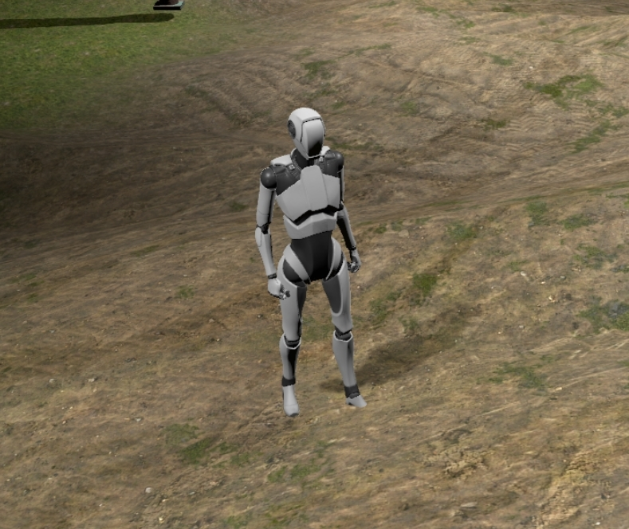

Below is a snippet of the ThirdPersonController.cs script that allows player movement.

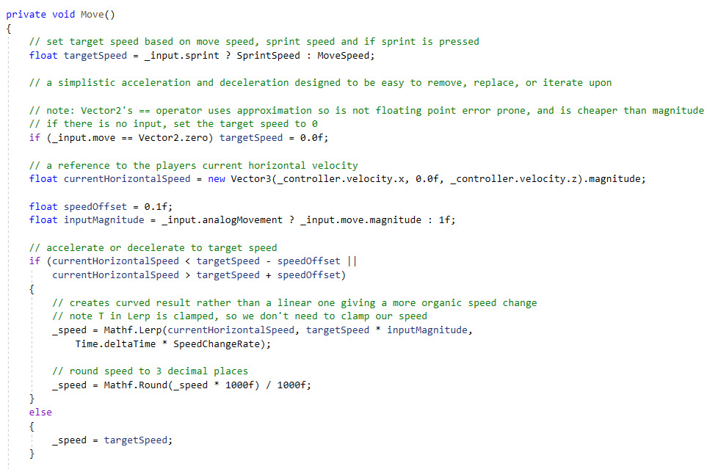

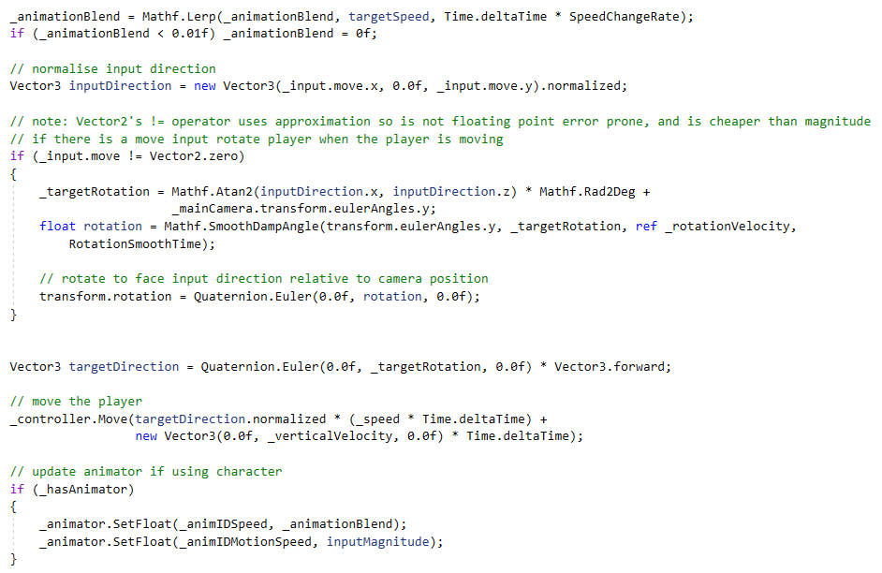

Maps

Level environments were designed in Unity to fit the theme and allow the player to explore an interesting landscape.

Some screenshots of these levels in the design view are shown below.

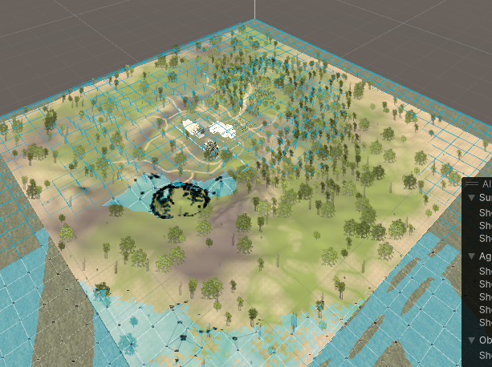

Levels

The way the player can beat the levels is to collect at least 3 crystals hidden around the map and reach the hidden end point before your health runs out (goes down by 1 every second).

Enemies

Enemies were implemented with full AI mind functionality to allow them to chase after the player. This provides an obstacle for the player in completing their task.

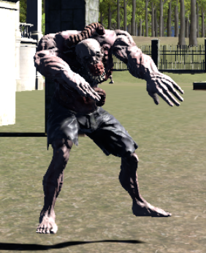

Collectables

Various items that the player can pick up were implemented into the game to help them navigate through and reach their goals.

One collectable that was implemented is the healthpack. This increases the player’s health upon contact with it. A screenshot of this item and its implementation is shown below.

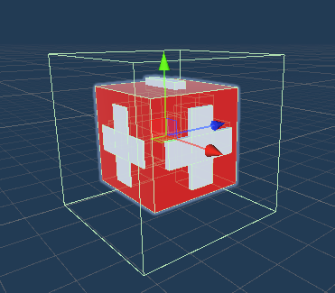

As shown below, interaction with this item calls the Heal method of the Player script.

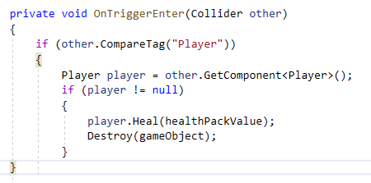

Multiplayer Mode

To implement some sort of multiplayer functionality a networking framework had to be utilized. We searched and went through trial and error with many of these frameworks over many months. We decided to pick Netcode for GameObjects, the very new framework which is still only on version 1.2.

Quick background of Netcode for GameObjects:

* Built on top of the Unity Entity Component System (ECS) architecture, which allows for efficient and optimized networking of game objects.
* Client-server model, where the server is the authority and controls the state of the game objects
* Uses "interest management" to minimize the amount of data that needs to be sent over the network, by only sending updates for objects that are relevant to a particular client's view of the game world.

A screenshot of when the networking implementation was first complete is shown below with two players.

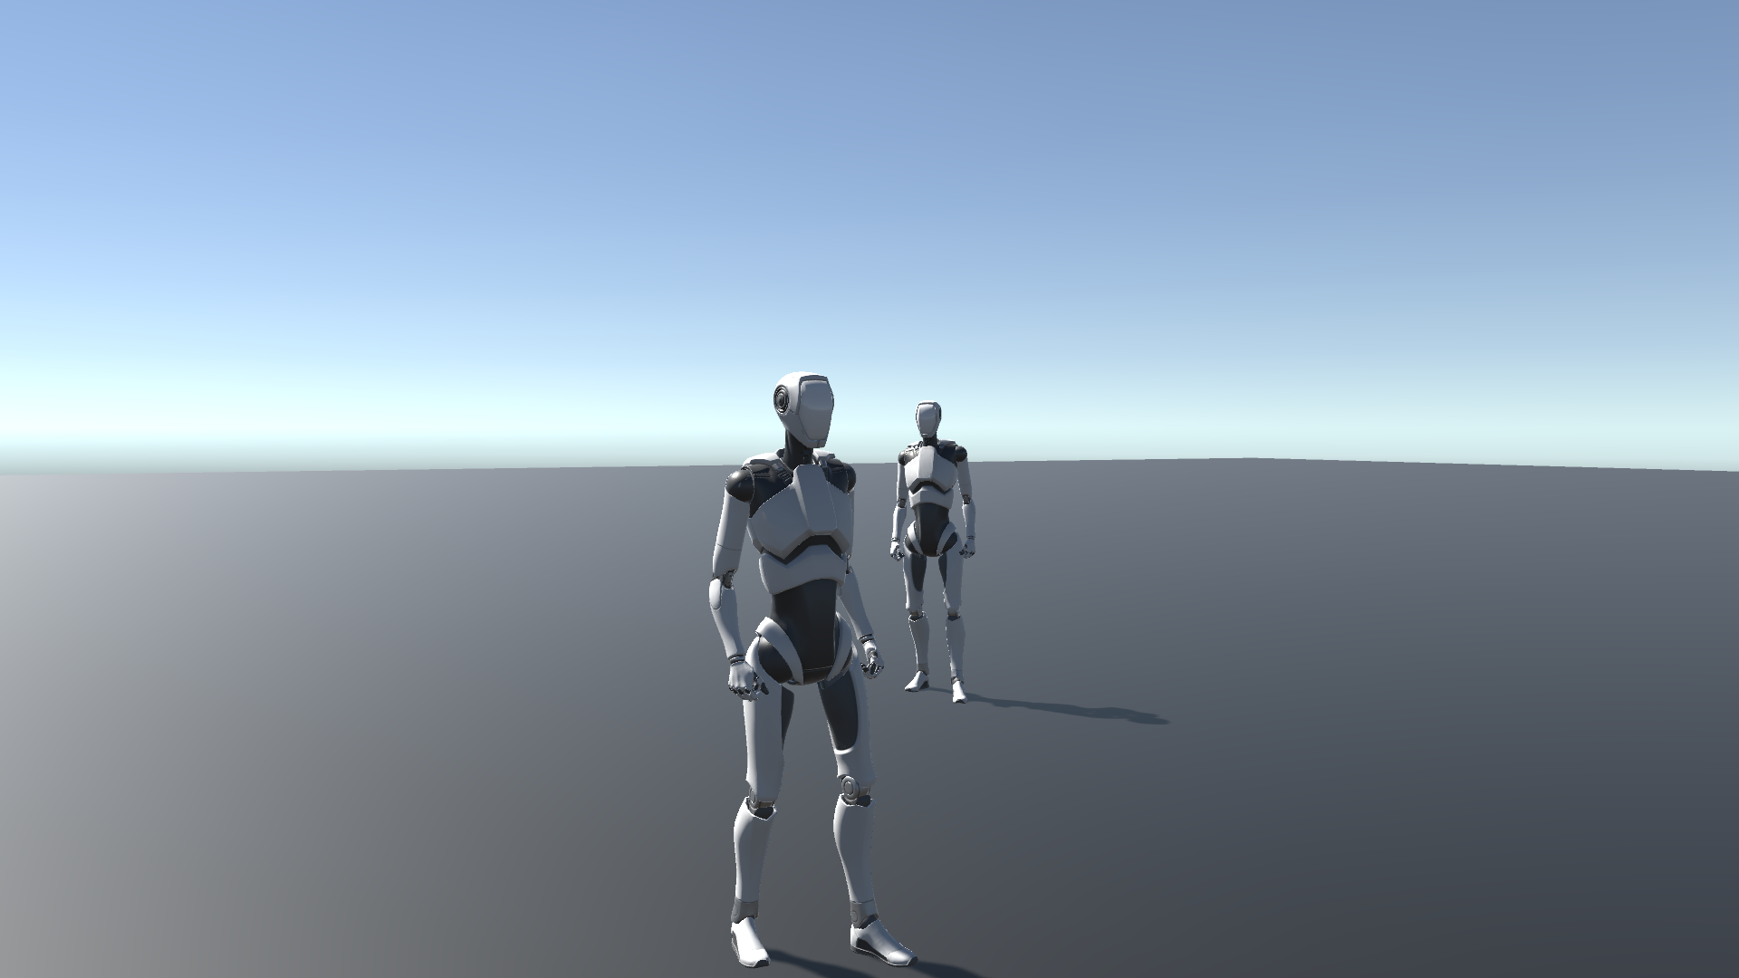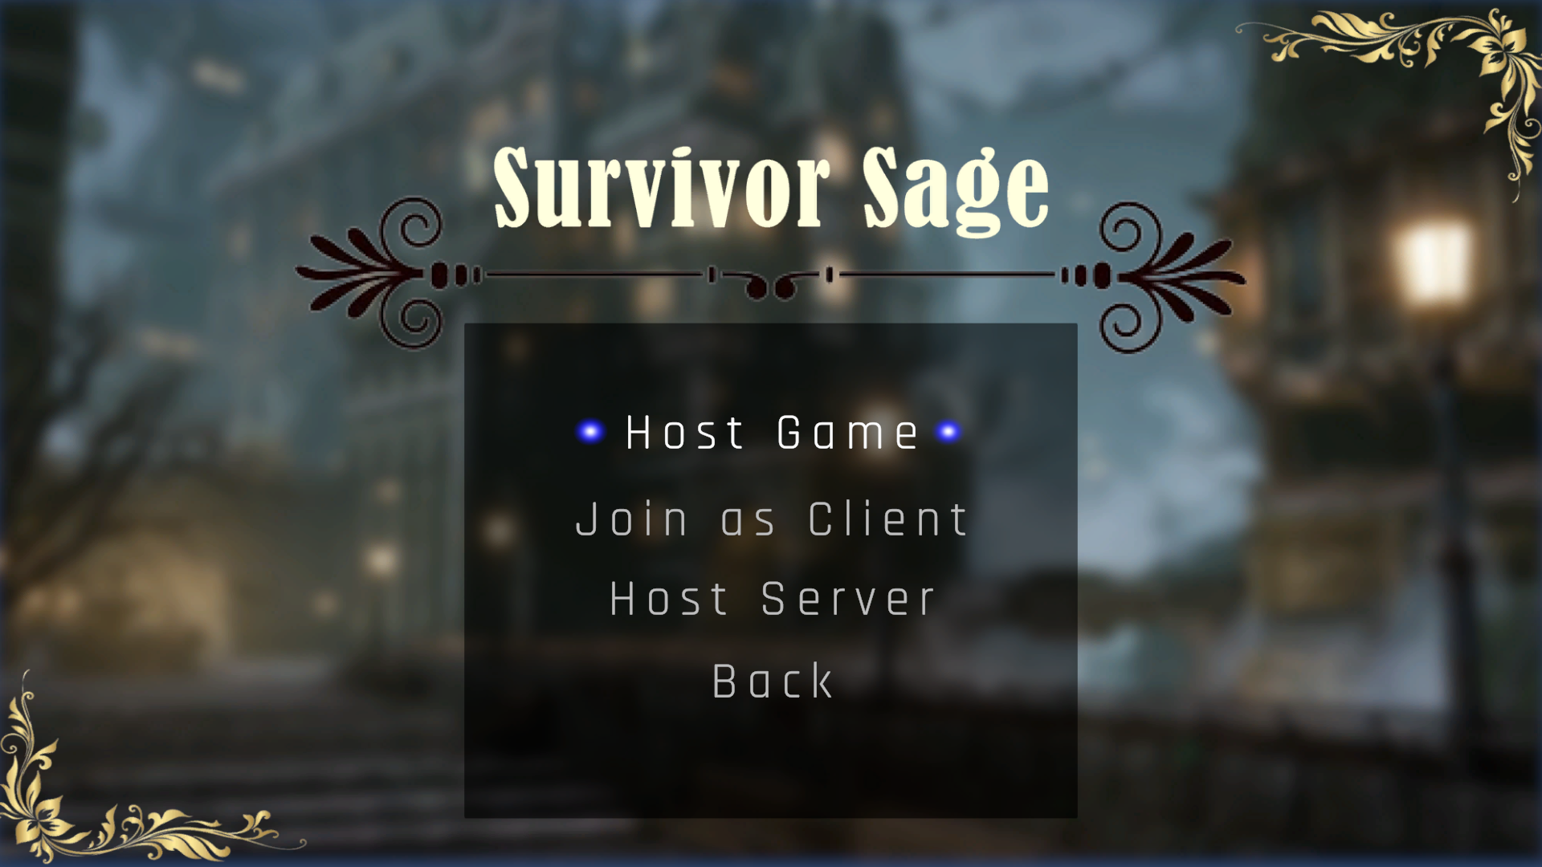

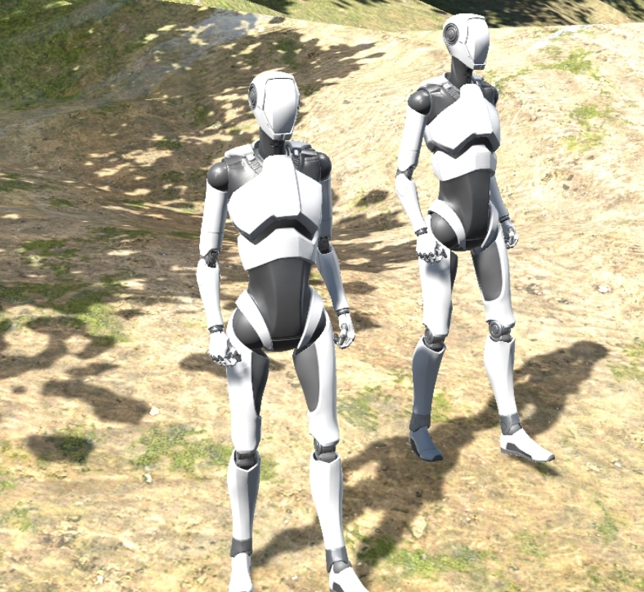

A character selection screen was also implemented for this multiplayer functionality.

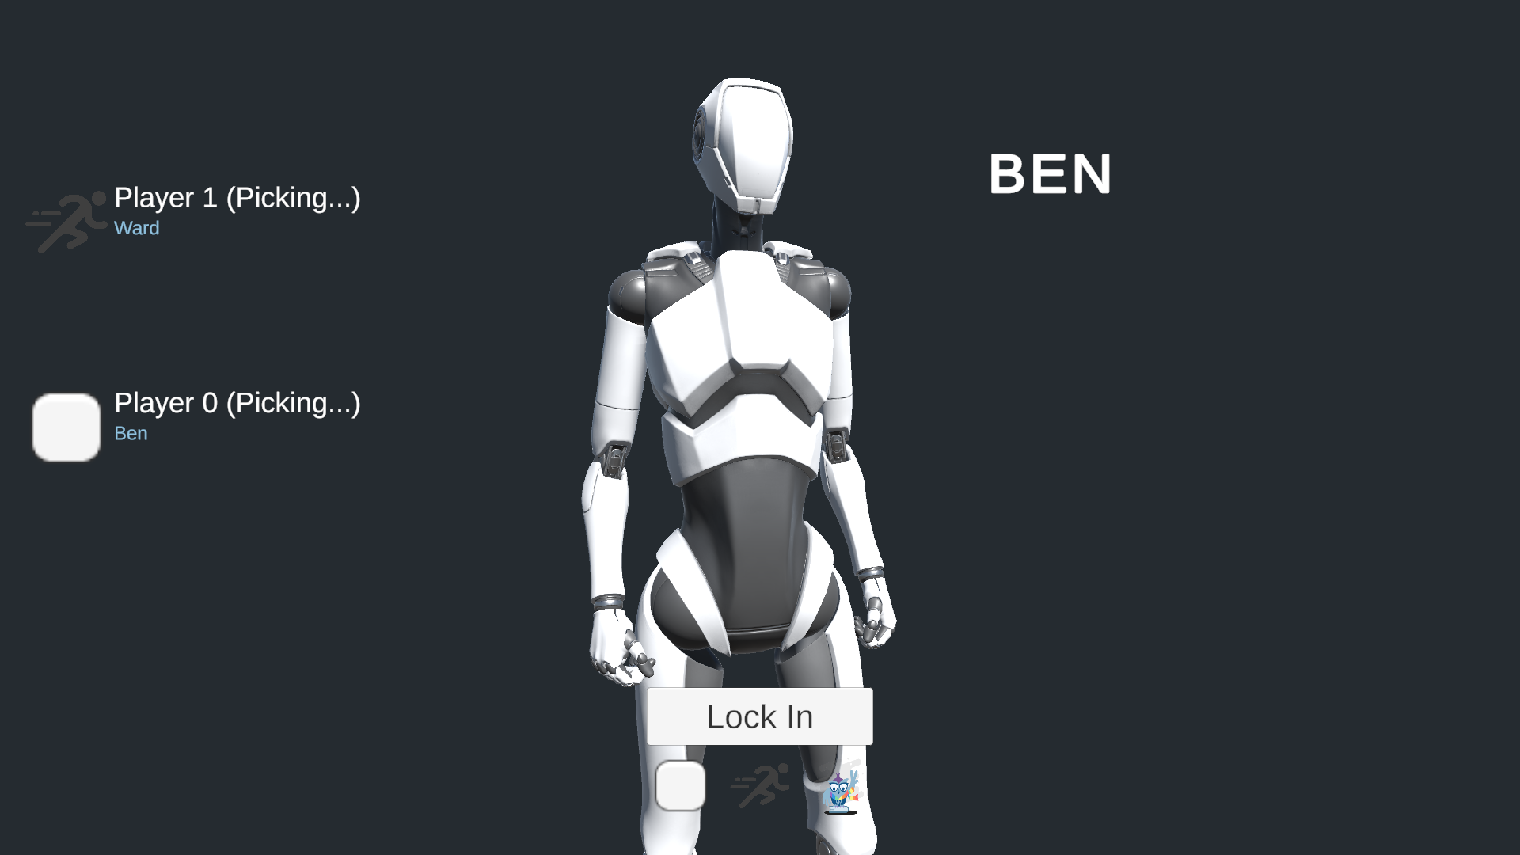

A snippet of the code that is used to start the server and add clients for players is shown in the ServerManager.cs script below.

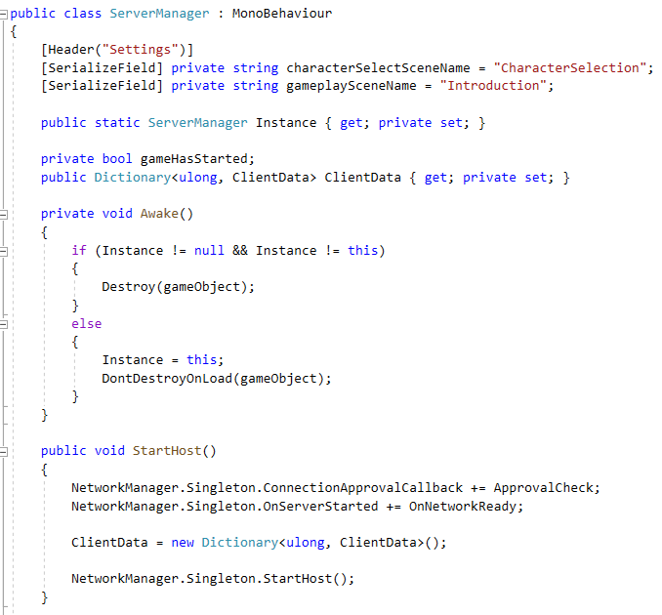

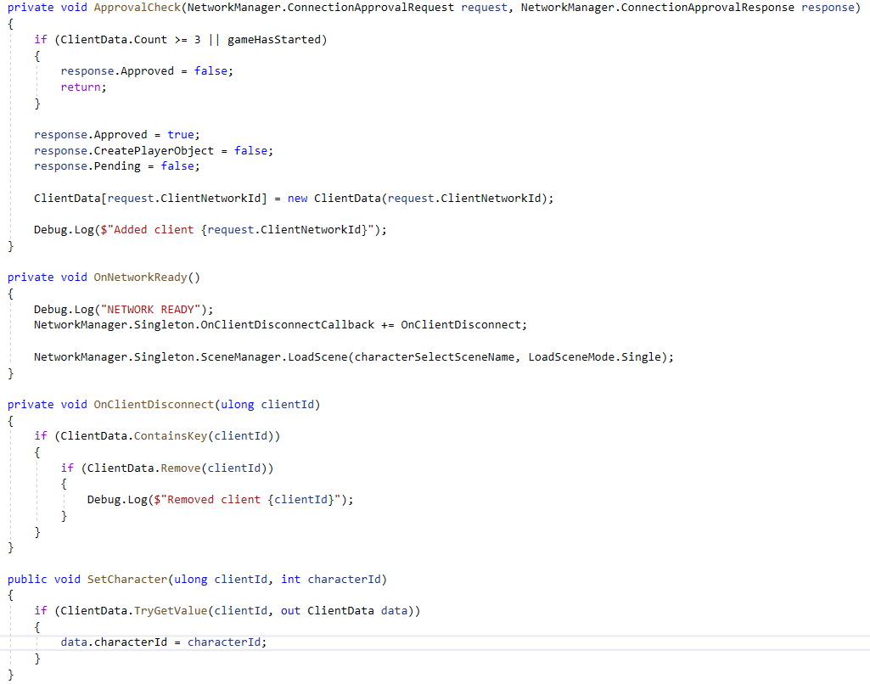

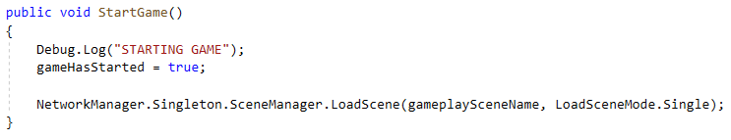

To implement the overall multiplayer functionality, all scripts had to be recreated with NetworkBehaviour as well so that they work over the network to show all players the activity.

**Project Demo**

A demo video was created for this game development project. This video was submitted along with this document but can also be found on youtube.

As seen here:

[*https://uwin365-my.sharepoint.com/personal/ahmed16r_uwindsor_ca/_layouts/15/stream.aspx?id=%2Fpersonal%2Fahmed16r%5Fuwindsor%5Fca%2FDocuments%2FRecordings%2FCall%20with%20Jason%20and%201%20other%2D20230415%5F231051%2DMeeting%20Recording%2Emp4&ga=1*](https://uwin365-my.sharepoint.com/personal/ahmed16r_uwindsor_ca/_layouts/15/stream.aspx?id=%2Fpersonal%2Fahmed16r%5Fuwindsor%5Fca%2FDocuments%2FRecordings%2FCall%20with%20Jason%20and%201%20other%2D20230415%5F231051%2DMeeting%20Recording%2Emp4&ga=1)

**Conclusions and Limitations**

In conclusion, we have spent this course developing this game project and have made many accomplishments but also encountered many challenges. These challenges have led to many limitations of the current game.

The challenges of the current version of the game are listed below:

1. Budget: Due to there being no budget for this game, only free assets were available for us to use. This limited potential quality of level building and character designs. This could be improved by spending money on higher quality assets in the future.
2. Time: Due to the heavy course loads of the members of the group, not enough time was allocated for this project. More time would allow for more features to be implemented and a better final product of a game.
3. Knowledge/Experience: Due to this being the first time many of us have done this type of work, this was a big learning experience and it took longer to implement things we had not done before. Now with experience in this field from this project, implementing these features would be more efficient in the future.
4. Communication: There was a lack of communication between group members that can be learned from and improved in future projects.

The limitations of the current version of the game are listed below:

1. Levels: The current version of the game has a limited number of levels. A future version would have more levels implemented to create a longer playtime.
2. Design: The current version of the game has very basic player and asset models. A future version would have these improved.

**Github Link**

The link to this project on github is:

<https://github.com/R-bjorn/Game-Demo>